Count files - Code Source

1-Count files - Ai Question - id 2
# Source: Person Source: Provided by: [Data Path: Persons Table -> ID Column: 1, Name_En Column: Motasem Essam] Written by: [Data Path: Persons Table -> ID Column: 1, Name_En Column: Motasem Essam] on [11/19/2025]
give me Python code to to choose folder by widnow then count files inside it and inside each subfolders and any other folders inisde subfolders

2-Count files - Ai Answer - id 2
# Source: AI Source: Provided by: [Data Path: Persons Table -> ID Column: 1, Name_En Column: Motasem Essam] -> From: [ChatGPT] on [11/19/2025]
Here is a clean Python example that:
- Opens a Windows folder picker (using tkinter).
- Counts all files inside the selected folder including all subfolders recursively.
- Prints totals and optional per-folder counts.
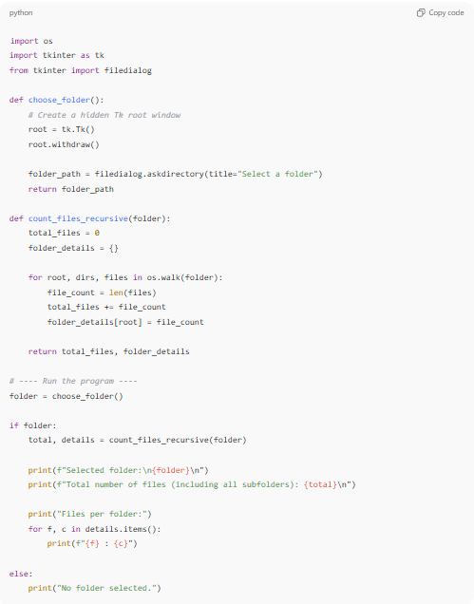
import os
import tkinter as tk
from tkinter import filedialog

def choose_folder():
# Create a hidden Tk root window
root = tk.Tk()
root.withdraw()

folder_path = filedialog.askdirectory(title="Select a folder")
return folder_path

def count_files_recursive(folder):
total_files = 0
folder_details = {}

for root, dirs, files in os.walk(folder):
file_count = len(files)
total_files += file_count
folder_details[root] = file_count

return total_files, folder_details

# ---- Run the program ----
folder = choose_folder()

if folder:
total, details = count_files_recursive(folder)

print(f"Selected folder:\n{folder}\n")
print(f"Total number of files (including all subfolders): {total}\n")

print("Files per folder:")
for f, c in details.items():
print(f"{f} : {c}")

else:
print("No folder selected.")
✔ What this script does
- Uses a Windows dialog to let you pick a folder.
- Walks through all nested subdirectories automatically (os.walk).
- Counts:
  - Total files
  - Files inside each individual folder
If you want enhancements (e.g., count only certain extensions, show a GUI, or export the results), just tell me!

3-Count files - Ai Question - id 2
# Source: Person Source: Provided by: [Data Path: Persons Table -> ID Column: 1, Name_En Column: Motasem Essam] Written by: [Data Path: Persons Table -> ID Column: 1, Name_En Column: Motasem Essam] on [11/19/2025]
first ignore any files inside this folder nameed .git
second give me array choose files name.exnesions which you will ignore it in count like any files with this Transfer.txt, Source.docx .gitattributes

4-Count files - Ai Answer - id 2
# Source: AI Source: Provided by: [Data Path: Persons Table -> ID Column: 1, Name_En Column: Motasem Essam] -> From: [ChatGPT] on [11/19/2025]
Here is an improved version of the script with your two requirements added:
✅ New Features
- Ignore any folder named .git (skip everything inside it).
- Ignore files with specific names or extensions (you can customize the list easily).

✔ Updated Python Code
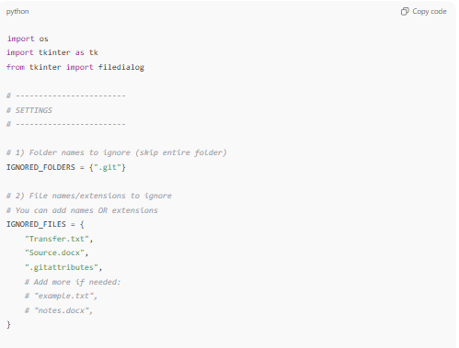
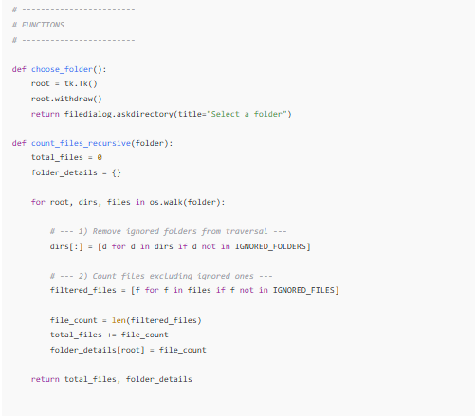
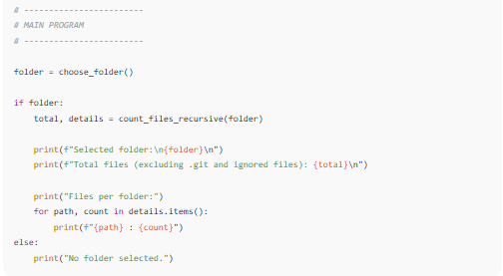
import os
import tkinter as tk
from tkinter import filedialog

# ------------------------
# SETTINGS
# ------------------------

# 1) Folder names to ignore (skip entire folder)
IGNORED_FOLDERS = {".git"}

# 2) File names/extensions to ignore
# You can add names OR extensions
IGNORED_FILES = {
"Transfer.txt",
"Source.docx",
".gitattributes",
# Add more if needed:
# "example.txt",
# "notes.docx",
}

# ------------------------
# FUNCTIONS
# ------------------------

def choose_folder():
root = tk.Tk()
root.withdraw()
return filedialog.askdirectory(title="Select a folder")

def count_files_recursive(folder):
total_files = 0
folder_details = {}

for root, dirs, files in os.walk(folder):

# --- 1) Remove ignored folders from traversal ---
dirs[:] = [d for d in dirs if d not in IGNORED_FOLDERS]

# --- 2) Count files excluding ignored ones ---
filtered_files = [f for f in files if f not in IGNORED_FILES]

file_count = len(filtered_files)
total_files += file_count
folder_details[root] = file_count

return total_files, folder_details

# ------------------------
# MAIN PROGRAM
# ------------------------

folder = choose_folder()

if folder:
total, details = count_files_recursive(folder)

print(f"Selected folder:\n{folder}\n")
print(f"Total files (excluding .git and ignored files): {total}\n")

print("Files per folder:")
for path, count in details.items():
print(f"{path} : {count}")
else:
print("No folder selected.")

✔ How to add more ignored files
Just add to the list:
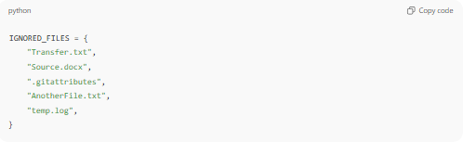
IGNORED_FILES = {
"Transfer.txt",
"Source.docx",
".gitattributes",
"AnotherFile.txt",
"temp.log",
}
You can add full names, with extensions.
✔ How to add more ignored files
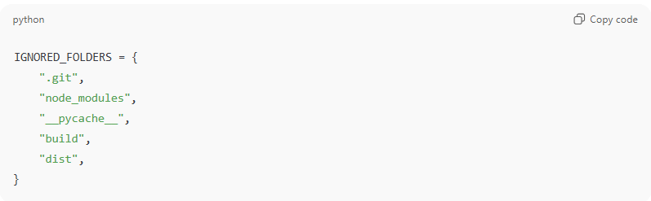
IGNORED_FOLDERS = {
".git",
"node_modules",
"__pycache__",
"build",
"dist",
}
Anything you put in this list will be completely skipped, including all files and subfolders inside those folders.

🔍 Important Notes
- Use only the folder name, not the full path.
Example: use "node_modules" not "C:/project/node_modules".
- The script will automatically skip these folders anywhere in the directory tree.

If you want to ignore files by extension only (e.g., ignore all .txt), I can enhance the script further — just tell me!

